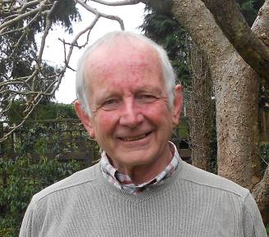  Michael Jeger  Department of Life Sciences, Imperial College London,  Silwood Park, Ascot, UK  Keynote Talk: “Emerging themes and approaches in plant virus epidemiology”  His areas of expertise cover quantitative plant disease epidemiology, especially in relation to modelling the interactions between plants, viruses and vectors; in particular how vector population dynamics, ecology and behaviour combine to influence transmission and determine the emergence and spread of virus disease | 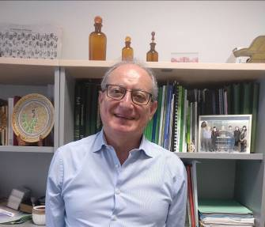  Fernando Garcia-Arenal  Centre for Plant Biotechnology and Genomics (CBGP, UPM-INIA). Madrid, Spain  Keynote Talk: “Virus host ranges and transmission dynamics in heterogeneous environments”  His main research interests include plant-virus interaction and co-evolution in all aspects of plant virology, from diagnosis for new diseases to the molecular mechanisms involved. More recently his research focuses on plant-virus coevolution and on how ecology modulates plant virus interactions and determines virus emergence

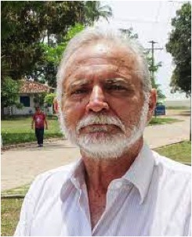  Armando Bergamin Filho  Department of Plant Pathology and Nematology. ESALQ. University of São Paulo, Piracicaba, Brazil  Keynote Talk: CANCELLED  He is best known for his work in epidemiology of diseases of tropical crops and the difference in strategies that tropical pathogens use to cycle infections over a broad range of environmental conditions |   Jan Kreuze  Crop and Systems Science Division Leader at International Potato Center (CIP). Lima, Peru  Keynote Talk: “Developing elements for global plant virus management: diagnostics, surveillance and modelling”  Experienced science leader with a demonstrated history of innovative research at basic and applied levels with a focus on virology. Skilled in Bioinformatics, high throughput sequencing, Molecular Biology, Biotechnology, Diagnostics and Virology

 | 
Hanu Pappu  Department of Plant Pathology. Washington State University,  Pullman, WA, USA  Keynote Talk: “Omics and Plant Virus Interactions: Potential Application in Virus Management” | Veronique Brault  Institut National de Recherche en Agriculture, Alimentation et Environnement, (INRAE). University of Strasbourg, Colmar, France  Keynote Talk: When plants and aphids are under the control of viruses!
His main research interests deal with the molecular biology of members of thrips transmitted tospoviruses (Bunyaviridae) and other plant viruses. He focuses on the characterization and control of viral diseases of horticultral crops including conventional and transgenic resistance, virus detection, and host virus interactions | Her area of expertise covers the molecular mechanisms of transmission of poleroviruses by aphids. More recently she has been studying the cross talk between the plant, the virus and the aphid to identify the deregulations induced by the viral infection in the plant which impact the aphid behavior and potentially virus transmission

  Cecilia Tamborindeguy  Department of Entomology, Texas A&M University TX, USA  Keynote Talk: “How does ‘Candidatus Liberibacter solanacearum’ manipulate plant and insect immunity?”  Her research focuses on understanding the mechanisms underlying plant pathogen transmission by insects such as: 1) how pathogens affect host plants and vectors, (2) what are the molecular mechanisms involved in pathogen transmission, and (3) how plants respond to insects and pathogens. | 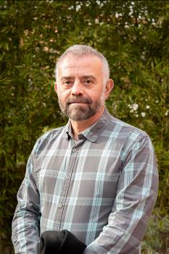  Tomas Canto  Margarita Salas Center for Biological Research (CIB-CSIC), Madrid, Spain  Keynote Talk: “Anthropogenic climate change and its impact on interactions between viruses and plants”  His research focuses on the molecular study of plant/RNA virus/vector interactions, investigating the functions of factors that are relevant to those interactions, and how they may be influenced by the surrounding environment.

